How to Choose Mountain Bike Gloves with Grip

Every mountain biker should, besides having a great bike and gear for it, have also great apparel for it. The mountain bike itself is not enough to make your ride comfortable.

Bicycle gloves are a crucial accessory for any biker type and we recommend you to purchase a pair. People, usually amateurs, forget to invest in good equipment and bike gloves are forgotten.

But before making your purchase you should do your research on the qualities mountain bike gloves should have. Luckily, here we will give you a brief summary of what is important for mountain bike gloves.

**To choose mountain bike gloves with grips, pick a material that is durable and resistant to any weather condition, and consider other characteristics such as the thickness and padding, the fingers design, the elasticity around the wrist, touchscreen compatibility, and the water-resistance.**

## Why do you Need Mountain Bike Gloves with Grips?

If you are still wondering why you need mountain bike gloves with grips we will give you the answer.

These gloves are not just a fashion statement, but they are one of the most important pieces of equipment when it comes to safety. **You need mountain bike gloves with grips because** they provide a firm grip on the handlebars and protect your hands from any harm. Additionally, they keep you warm during cold weather, and provide breathability during hot weather.

They provide additional cushioning and comfort especially when riding on bumpy and rocky terrain. They eliminate blisters, scratches and bruises, making your ride more comfortable. Some even prevent carpal tunnel syndrome and joint injuries. This is a much needed piece for mountain biking.

## What Factors to Consider When Buying Gloves with Grips

There are some key factors that need to be considered when making a purchase. **Factors to consider when buying gloves with grips include** durability, weather, comfort, protection and material.

Durability must be one of the key factors when choosing mountain bike gloves. They are constantly exposed to severe weather conditions and other damage. The durability of gloves depends on the material, padding and stitching.

Mountain bikers go on rides the year round and are exposed to various climates- from hot summers to freezing winters. Therefore, it is advisable to get mountain bike gloves that are suitable for all seasons. There are some that are specifically made for hotter or colder weather.

Since you are riding on rocky terrain, you should purchase gloves with padding on the grips and maybe the knuckles to provide an enjoyable ride. It is also important from which material the gloves are made of. Make sure to get gloves that are breathable as it is important to keep your hands cool during warm seasons, and also insulation to maintain blood flow during colder months.

Every type of gloves is made differently and not all provide the same level of protection. Some have a thinner and some a thicker layer of padding, depending on the longevity of the ride and the terrain you ride on. Also, get gloves that protect you from different weather conditions. This all mostly depends on the gloves’ material. The gloves are usually made from synthetic, leather materials, with the padding made out of silicone, foam, rubber and gel pads.

## Mountain Bike Glove Materials and How They Affect Grip

Comfort, grip quality, durability, protection - everything comes down to mountain glove material. As it was mentioned earlier, mountain bike gloves are made from synthetic materials such as acrylic, polyester, leather, and the padding is made from silicone, foam, rubber, gel pads.

### Synthetic Leather

Synthetic leather is perfect for colder and rainy days as it is water and wind proof and maintains warmth. This material with great effectiveness wicks sweat away and does not compromise the grip and is resistant against slides in the dirt.

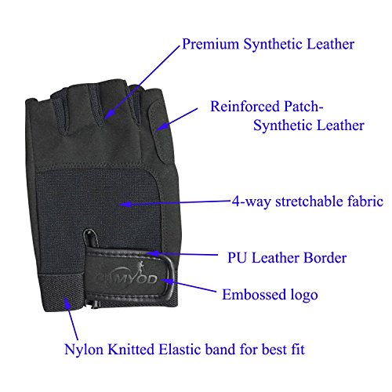

### Synthetic Suede

Synthetic suede is an animal friendly material that resembles natural suede, but is more durable, less expensive and easy to maintain. It is best that this material is on the palms and the fingers. It has water repellent qualities, so it can be safely and easily cleaned, and cannot be easily damaged by water. This material is much more durable than its natural counterpart and these mountain bike gloves will last you a long time.

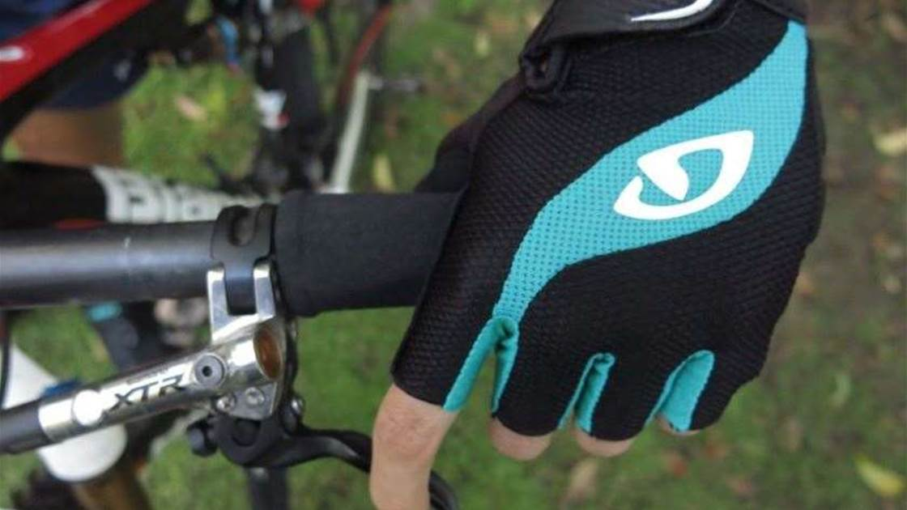

### Silicone Padded

It is essential that mountain bike gloves have padding to absorb vibrations. Without it, you will lose control over your bike. Many brands add silicone details on the palms to ensure a firmer grip and to provide impact protection. However, do not get too bulky and too padded gloves as you will not feel your bike and will not have a proper connection with your handlebar to maintain control. Silicone padding is provides great absorption, but will not last too long.

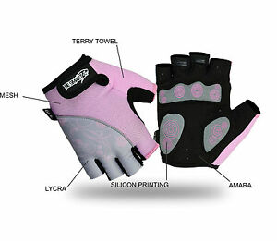

### Rubber Padded

Rubber pads are a bit thicker than silicone pads, but still absorb vibrations and reduce impact. They tend to be bulky at times, so make sure you get gloves with thinner pads that will allow you to properly function and control your bike. Rubber pads are very durable and will not go out easily, but they can be hard and firm which might hurt your hands or cause numbness, which is another reason to get thinner ones.

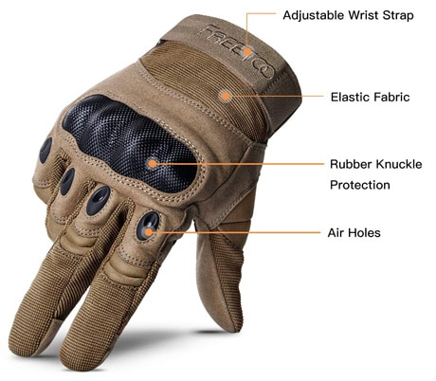

### Textured Gloves

Textured gloves are made from various materials that are anti-slip and usually water resistant, so you can have a pleasant ride during rainy and snowy days. Synthetic leather and suede also fall into this category. These gloves are made form a combination of materials such as elastic and rubber, to make that textured look and provide adherence. Anti-slip materials provide adherence to the handlebars. These are usually materials that are lightweight, thin and are highly ventilated made for hotter climates, but there are also the ones with thicker backs made for colder weather.

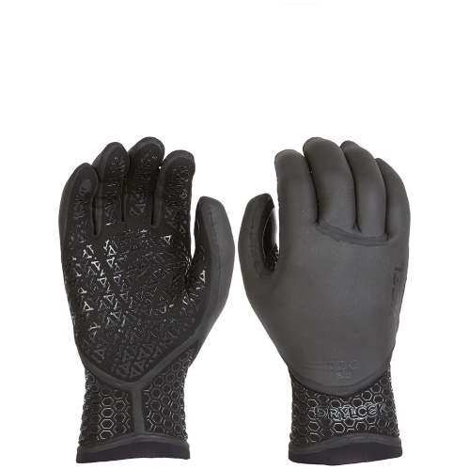

Below is a summary of different mountain bike glove material with their pros and cons:

|  |  |  |  |  |
| --- | --- | --- | --- | --- |
| Mountain Bike Glove Material | Pros | Cons | Amazon Product Example | Price Range |
| Synthetic Leather | Lightweight, breathable, moisture-wicking | Not enough padding | [Giro La DND Women's Mountain Cycling Gloves](https://www.amazon.com/Giro-DND-Cycling-Glove-Womens/dp/B00NBAKFL0/ref=sr_1_7?dchild=1&keywords=synthetic+leather+mountain+bike+gloves&qid=1623744349&sr=8-7) | $24.33- $31.34 |
| Synthetic Suede | Durable, wrist support, breathable, enhanced grip | Not the most protective | [EVO Palmer Pro Trail Full Finger Cycling Gloves](https://www.amazon.com/Palmer-Trail-Finger-Gloves-Unisex/dp/B083QNMY5M/ref=sr_1_7?dchild=1&keywords=synthetic+suede+mountain+bike+gloves&qid=1623744579&sr=8-7) | $23.52- $29.99 |
| Silicone Padded | Shock absorption | Wears out quickly | [K-mover Non-Slip Cycling Gloves Mountain Bike Gloves](MTB%20Mountain%20Bike%20Bicycle%20Cycling%20Half%20Finger%20Gloves%20GEL%20Silicone%20Pad%20Fingerless) | $4-$35 |
| Rubber Padded | Warm, perfect for winter, touch screen finger, waterproof, non-slip | A but thick | [Axdwfd Winter Cycling Gloves Full Finger Mountain Rubber Pad Touch Screen Mountain Bike Gloves](https://www.amazon.de/-/en/Axdwfd-Winter-Cycling-Gloves-Mountain/dp/B08L7Y7Y86) | $20-$40 |
| Textured | Breathable, slip resistant | Needs more padding | [Cool Change Cycling Gloves Mountain Bike Gloves SBR Padded Shockproof](https://www.amazon.com/Cool-Change-Mountain-Shockproof-Breathable/dp/B08721VTLJ) | $12.80- $15.99 |

## Other Factors to Consider when Choosing Mountain Bike Gloves

We covered all of the key factors that need to be taken into consideration when buying mountain bike gloves. We will also mention a couple of other factors that might be valuable to you.

## Thickness/Padding

Thickness of gloves depends on the material from which they are made of. Thicker materials or more padding (especially with hard material) can cause bulkiness which limits your hand movements and you do not fully feel your bike and have control over it. On the other hand, having gloves that are too thin does not offer much protection and are not that comfortable. More padding is for those who ride at a high intensity level, like rocky terrains. Be careful what kind of material you choose because some of them cause sweatiness more than others.

## Finger length

Unfortunately, manufacturers have different measurements, and the same size is not always the same size. Therefore, measure your hand size before purchasing your gloves. Measure the length of your hand from the top of the middle finger to the bottom of the palm, and the width just below your knuckles. See the size chart from the glove brand you like, and order your gloves. This goes if you are an online shopper. It is definitely safer to go to the store and try the gloves to be 100% sure the gloves fit you.

## Elastic or Velcro Wrists

Despite choosing the right glove size and is secure and tight on your hands, you will also look for gloves that are secured around the wrists. There are two types- elastic and Velcro wrists. Both of them have pros and cons. The elastic ones are lighter and simpler, but the elastic will loosen after some time. Velcro are very easy to put on and take off, but the hook can get damaged if it is not in the right position. Elastic ones might be more for those who ride in warmer weather, and Velcro for winter.

### Touchscreen Compatibility

This is a type of glove which is made from a material that is compatible with smartphone and tablet touchscreen. This was made possible with conductive material in the fingertips, mostly the index finger, and sometimes all fingers and thumb. Having these gloves in your possession frees you from answering a call with your nose or taking of your gloves.

### Full Finger or Half Finger

This is an everlasting debate- fingers or fingerless. This is another case of pure personal preference. Fingerless mountain bike gloves are usually recommended to warmer weather. Some maybe feel that these gloves give them more control since. The disadvantage of fingerless gloves is that when the fingers get sweaty or dirty they become slippery. Consequently, you cannot have a firm grip! And they do not have that much padding and your fingers are out on the open and can get injured.

Full finger gloves protect your whole hand, and have more padding. They can be a nuisance during the summer, but they are excellent for other weather conditions. You still maintain full control over your bike even with covered fingers.

### Water-resistance

Make sure you get the material that is water resistant, since some materials do not function well in the rain and will make your hands slippery which can result in a crash. Those that are resistant will not allow water to get to your skin which will make your ride easier.

### Make Sure The Glove Fits Properly

A good pair of mountain bike gloves should not even feel like gloves, but a part of hands, like a second skin. A glove’s fit plays a crucial role in its comfort and performance. There should not be almost any room between the gloves and the hands, allowing them to slip off or move while riding, but they should not be too tight to limit movement or be uncomfortable.

Carefully measure your hands so you do not order the wrong size.

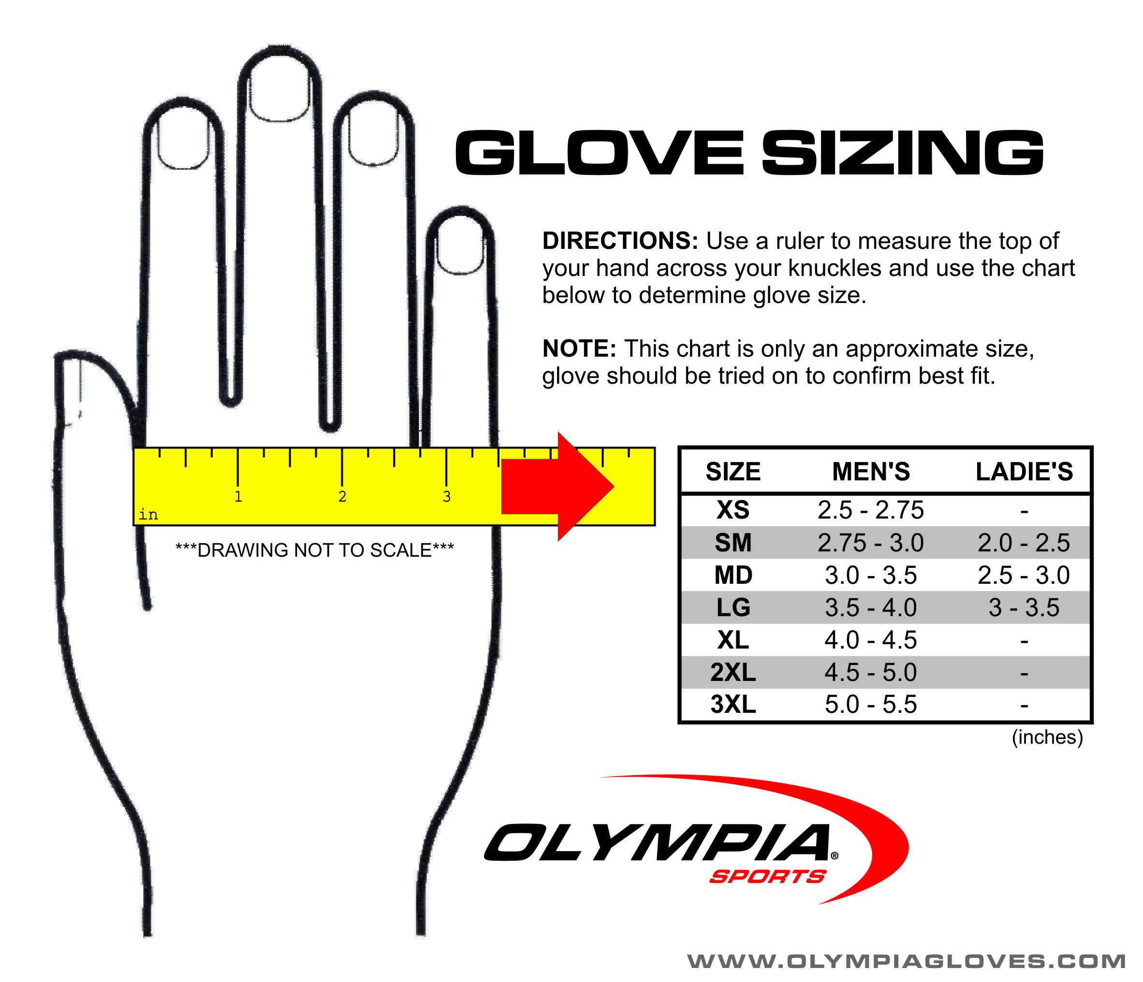

### Get Gloves That Can Be Used In Any Weather Conditions

You will find a wide array of mountain bike gloves that are suitable for all weather conditions. You also have gloves that are specifically designed for certain weather- hot, cold, rainy, and so on. But in the end everything is about your preference and on what kind of weather you ride the most.

A large number of mountain bike gloves are made from synthetic materials like acrylic, polyester, leather and suede. Some are even made from natural leather and suede.

|  |  |  |  |  |
| --- | --- | --- | --- | --- |
| Other Considerations When Choosing Gloves and Grips | Pros | Cons | Product Example | Why Is this Glove Recommended |
| Thickness/Padding | Comfortable, prevents injuries | Bulkiness | [Dakine Cross](https://www.amazon.com/dp/B079THJVWM?tag=outdoocom-20&linkCode=ogi&th=1&psc=1) | Solid grip, knuckle padding, works with touchscreen |
| Finger Length | Great fit and feel, breathable | Not so tight at the back of the hands | [Royal Racing Core Gloves](https://www.amazon.co.uk/dp/B01LXRUSUF/ref=asc_df_B01LXRUSUF1623668400000/?creative=22374&creativeASIN=B01LXRUSUF&linkCode=df0&tag=monetizer-amazon-bikeradar-21&ascsubtag=post-bikeradar-400492-its-txt-pos) | True size |
| Elastic Wrists | Comfortable, breathable | Fingerless | [HNOOM Cycling Gloves](https://www.amazon.co.uk/HNOOM-Shock-Absorbing-Anti-Slip-Mountain-Breathable/dp/B089YTN4GC/ref=sr_1_25?dchild=1&keywords=elastic+wrist+mountain+bike+gloves&qid=1623775889&sr=8-25) | Anti-slip, easy to take on and off |
| Velcro Wrists | Comfortable, padding, | Slightly bulky | [Troy Lee Designs 2020 Men's Air MTB Gloves](https://www.amazon.co.uk/Troy-Lee-Designs-Gloves-Orange/dp/B084Q9PKX2/ref=sr_1_7?dchild=1&keywords=troy+lee+designs+air+gloves&qid=1623776118&sr=8-7) | Good for all weather |
| Half Finger | Gel on palm | Sizing | [FOX Bike Gloves Short Finger Ranger Gel Dark Fatigue](https://www.amazon.co.uk/dp/B07982KV83?linkCode=osi&th=1&psc=1&tag=monetizer-amazon-bikeradar-21&ascsubtag=post-bikeradar-400492-its-txt-pos) | Secure, touchscreen compatibility |
| Full Finger | Perfect fit, light, breathable | A bit expensive | [Troy Lee Designs 2020 Ace Gloves](https://www.amazon.co.uk/dp/B079KYX842?linkCode=osi&th=1&psc=1&tag=monetizer-amazon-bikeradar-21&ascsubtag=post-bikeradar-400492-pcs-txt-pos) | Secure, grip feel |
| Water-resistance | Warm material, wind and water proof | Finger seams are prominent | [HHORD Cycling Gloves](https://www.amazon.co.uk/HHORD-Waterproof-Non-Slip-Glovessuitable-Mountain/dp/B07ZFD5NQP/ref=sr_1_5?dchild=1&keywords=water+resistant+mountain+bike+gloves&qid=1623776454&s=clothing&sr=1-5) | Anti-slip, good for all weather |
| Touch Screen Compatibility | Touchscreen compatible, warm | Bulkiness | [GORELOX Winter Warm Gloves](https://www.amazon.co.uk/GORELOX-Touchscreen-Windproof-Anti-Slip-Climbing/dp/B07XWLSSXG/ref=sr_1_5?dchild=1&keywords=Specialized+Trail+Thermal+Gloves&qid=1623776579&s=clothing&sr=1-5) | Anti-slip, for winter, windproof |